Project Design Phase-II
Data Flow Diagram & User Stories

Date | 19 February 2026
Team ID | LTVIP2026TMIDS78575
Project Name | shopsmart: your digital grocery store experience
Maximum Marks | 4 Marks

Data Flow Diagrams:

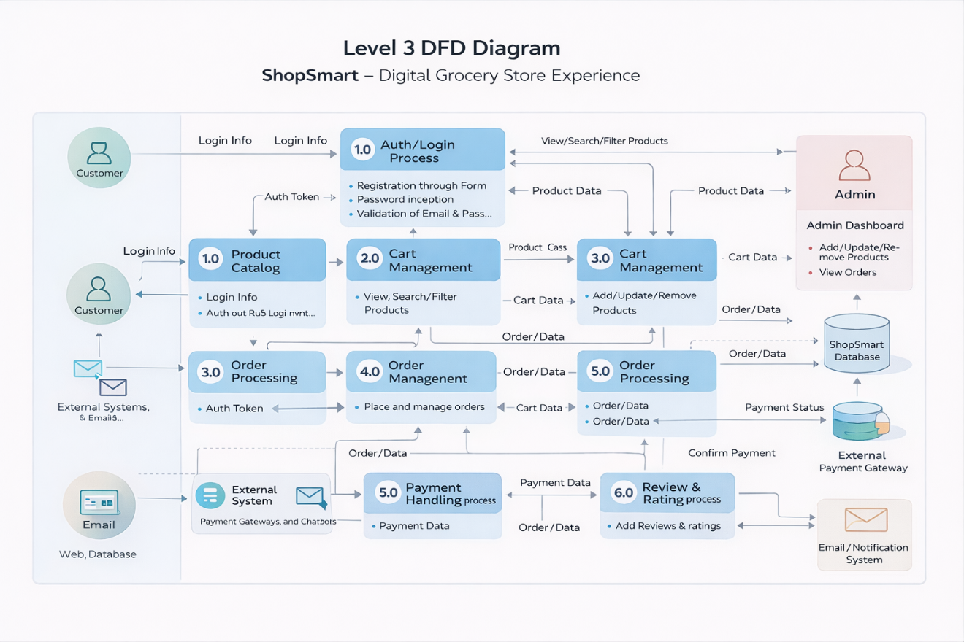

User Stories
User Type | Functional Requirement (Epic) | User Story No | User Story / Task | Acceptance Criteria | Priority | Release
Customer (Mobile) | Registration | US-1 | As a user, I can register using email & password | Account is created and user is redirected to dashboard | High | Sprint-1
Customer (Mobile) | Login | US-2 | As a user, I can login using email & password | User authenticated and session created successfully | High | Sprint-1
Customer (Mobile) | Product Browsing | US-3 | As a user, I can search and filter grocery products | Relevant products displayed based on filters | High | Sprint-1
Customer (Mobile) | Cart Management | US-4 | As a user, I can add/remove items from cart | Cart updates correctly with total price | High | Sprint-1
Customer (Mobile) | Order Placement | US-5 | As a user, I can place an order with selected products | Order ID generated and confirmation displayed | High | Sprint-2
Customer (Mobile) | Payment | US-6 | As a user, I can pay via UPI / Card / Wallet | Payment successful and receipt generated | High | Sprint-2
Customer (Web) | Order Tracking | US-7 | As a user, I can track my order status | Real-time order status is visible | Medium | Sprint-2
Administrator | Product Management | US-8 | As an admin, I can add/update/delete products | Product catalog updates instantly | High | Sprint-1
Administrator | Order Management | US-9 | As an admin, I can view and manage customer orders | Order status updated correctly | High | Sprint-2
Customer Care Executive | Support Management | US-10 | As a support executive, I can view and resolve customer issues | Support tickets resolved and status updated | Medium | Sprint-3

